Abstract
Elections are essential defining characteristics of any democracy in which citizens express their choice or articulate their opinions during voting. Voting systems have progressed from simple handwritten ballots to internet voting system in bounds and leaps. This venture intends to create elegant voting system based on facial identification technology that allows every voter in INDIA to vote from anywhere in India at the near polling booth in their location. This venture is used to keep biometric security at a high level. The voter information is saved in the server database. Before beginning the voting procedure, the voter must position in facade of the computer, where the camera will examine the voter’s picture. The micro- controller reads the information and delivers it to the web application through the serial port. The individual record is maintained by the web application software. If a person’s age is less than 18 years old, and he tries to vote again using his face sample, the web page will indicate that he is not entitled to vote. After the voting process is over, the election commission may log in and examine the results of the election. It can also reset the votes and update the candidate results.

In recent years, technology-driven advancements in voting systems have focused on enhancing security, accessibility, and convenience. This paper introduces a novel ”Smart Voting System” incorporating facial recognition technology, aimed at streamlining voter verification and reducing fraud. The system leverages real-time facial recognition to authenticate voters, eliminating the need for traditional ID cards or manual verification processes. Through the use of a high-accuracy facial recognition model, the system ensures that only registered voters can cast their votes, minimizing risks associated with voter impersonation and unauthorized ac- cess. Additionally, the smart voting platform is designed to be user-friendly, provid- ing a seamless and efficient voting experience that reduces queue times and improves overall voter engagement. Extensive testing and simulations demonstrate that this approach can significantly enhance the accuracy and reliability of voter identifi- cation, while maintaining privacy and data protection standards. The proposed solution offers a scalable and secure alternative for modernizing electoral processes, with potential applications in local, national, and organizational elections.

Table of contents Contents

- Chapter 1 4
  - Problem statement . . . . . . . . . . . . . . . . . . . . . . . . . . . . . . 4
  - Introduction . . . . . . . . . . . . . . . . . . . . . . . . . . . . . . . . . . 4
  - Existing Systems . . . . . . . . . . . . . . . . . . . . . . . . . . . . . . . 5
  - Advantages and Disadvantages . . . . . . . . . . . . . . . . . . . . . . . . 6
    - Advantages: . . . . . . . . . . . . . . . . . . . . . . . . . . . . . . 6
    - Disadvantages: . . . . . . . . . . . . . . . . . . . . . . . . . . . . 6
- Chapter 2 7
  - Literature Survey . . . . . . . . . . . . . . . . . . . . . . . . . . . . . . . 7
- Chapter 3 9
  - Feasibility Study . . . . . . . . . . . . . . . . . . . . . . . . . . . . . . . 9
  - Technical Feasibility . . . . . . . . . . . . . . . . . . . . . . . . . . . . . 9
  - Operational Feasibility . . . . . . . . . . . . . . . . . . . . . . . . . . . . 9
  - Economic Feasibility . . . . . . . . . . . . . . . . . . . . . . . . . . . . . 9
  - Schedule Feasibility 10
  - Tools and Technology used 10
- Chapter 4 11
  - Scope 11
  - Objectives 11
- Chapter 5 12
  - Facilities Required 12
    - Product Functionality 12
    - Hardware Requirements 12
    - Software Requirements 12
    - Performance Requirements 12
- Chapter 6 13
  - System Diagram 13
  - System Architecture 13
  - High level Architecture Design 13
- Chapter 7 14
  - code snippet 14
- Chapter 8 17
  - Conclusion 17
- References 18

Chapter 1

Problem statement
The basic methodology as applied to online voting systems would involve giving voters realistic voting tasks to accomplish using a variety of ballot design. Voting task per- formance is measured using variables such as accuracy, time and workload. The voting server collects the vote and filters out duplicate or invalid votes. Each voter can then check his vote online to ensure that his vote has been counted.

Introduction
Election plays an important role in such a huge democratic country like India where the leader is elected by residents.Elections preserve a truthful state functioning, as they pro- vide people the choice to select their personal government. So the election ought to be an unfastened and truthful process. Every citizen of a democratic country has a right of voting with his/her own choice. One of the fundamental issues in the conventional demo- cratic framework is that it expends bunches of labor and resources.Also some humans can be worried about illegal publications of movement at some point of this manner of elec- tion or its preparation. There are some disadvantages of the conventional election voting process which is being used in our country such as machine stops working, chances of brutality, time consuming, resource consuming, spot arranged etc. Many people couldn’t vote because the voter has to reach the poll booths to vote or some people like those who are living far away from their original birth place where they are allowed to vote. So to get rid of their drawbacks, a new System is introduced i.e. Online Voting System, which provides accuracy, security, flexibility, mobility etc. An online voting System in a web based application to use in the election process. Initially ballot paper technique was used in the election process. Then the Electronic Voting Machine comes, these are easy to store the data and easily manageable. These are more secure than the ballot paper and less time consuming.Now, we proposed a system with biometric authentication to make the voting process more secure and reduce the time taken in the voting process. By the use of this, the electorate can solidify their vote for his or her preferred candidate through the use of their system. We use Face detection and Recognition Technology for authentication of citizens that he/she is the proper consumer or not. We provide many modules in which admin can login withinside the tool and show the numerous operations. If both images are the same then the voter can cast his/her vote.

Existing Systems
The existing system is not too effective. At present there are two types of voting methods, they are:
- Ballot Voting
- EVM Voting

Ballot Voting
A ballot is a device used to cast votes in an election, and may be a piece of paper used in secret voting. In this the voter is given a paper which consists of all the party symbols along with representative names in it. Here, people come to the polling booth, take the ballot paper and vote by putting a stamp on the desired party symbol. Finally, the ballot paper is folded and dropped into the ballot box. At last, the votes are counted by the Election commission officers.

EVM (Electronic Voting Machine) Voting
An EVM is a device which is used for voting. This machine consists of party symbols along with the representative’s name and a button at the end for each and every party name. The voters come near the EVM machine after completion of their verification at the early level before voting. After verification the voter goes near the EVM and casts their vote by pressing the button. The above procedures are not so accurate as there may be possibility for the false/fake voting. The ballot papers may be lost at the time of counting which may affect results of the particular area or people may miscount the number of votes which leads authority into wrong hands. EVM machines sometimes get corrupted and polling gets stopped temporarily and a lot of time is wasted or EVM may be tampered and the casted votes may be polled to a particular party only, even the vote is casted to different candidates or parties. This may lead authority into the wrong hands.They also lack security as one’s vote can be casted by another voter or even a miscellaneous person. This factor is known as fake voting. Without proper authentication there is a possibility of fake voting. So, the existing system is not efficient for voting. Even though there is very little false/fake voting, this minor setback can turn the results in the opposite direction.

Advantages and Disadvantages

Advantages:
      - Enhanced Security and Fraud Prevention
      - Efficient and Faster Voter Verification
      - Increased Accessibility and Convenience
      - Data Accuracy and Integrity
      - Scalability for Large-Scale Elections

Disadvantages:
      - Privacy and Data Security Concerns
      - Potential for Technical Issues
      - Risk of Bias and Inaccuracy
      - High Implementation Costs
      - Public Skepticism and Acceptance

Chapter 2

Literature Survey
- In “AMNA QURESHI” [1], this paper describes, designing a polling system that provides flexible polling, device fingerprint to allow multi-factor authentication for differ- ent devices used by the voter, zero-watermarking of polling code sheets, and generation of polling tags. More specifically, the main contributions of this paper are as follows: Un- like most of the remote voting schemes, a 3- layered authentication scheme is designed to provide access tone authenticated voter only. The proposed multi factor authentication scheme employs device fingerprinting to recognize the computing device that the voter is utilizing to login. Based on the results of the fingerprint the voter is required to input his/her authentication factors (possession, biometric) to establish his/her identity.

- In “Ishani Mondal”, this Usually a face recognition module comprises of the following In this paper we have proposed a face recognition based on the features ex- tracted by a convolutional neural network from the captured image of a voter. If the captured image’s features match with those existing images stored in the database, the result is considered as positive and the voter is asked to cast vote for a political party. Once the vote has been casted, all the facial alignment details pertaining to the voter gets deleted from the system, so that if the same voter comes for voting, the system detects the maliciousness and prevents it instantly.

- In “Anooshmita Das”, In this proposed design, the viability study of the emerging technology NFC, in conjunction with biometric is done. This technology allows communication between the NFC card and the device equipped with the reader when they are brought together within less than five centimeters apart in a very secured and reliable manner, which ebbed the complicacy and preventing from the malicious attacks or frauds. Once the user is verified, the person can proceed to the next level of bio- metric authentication. To make the system more stringent and robust, another layer of security is reinforced through the use of biometric fingerprintidentification as every indi- vidual has unique fingerprints.Biometrics is the science and technology that deals with analyzing the biological information or data. Biometric logistics operates by procuring fingerprints from an individual, then decoction of a feature set from the acquired data, and comparing this feature set with reference to the template set stored in the database. Using fingerprint matching is very reliable and popular biometric technique in personal identification process as it generates solemnity while stressing on building or cultivating voter confidence.

- In the paper “Secure and Electronic polling system”, the authors AMNA QURESHI, DAVID MEG´IAS, HELENA RIFA`POUS described SeVEP, an electronic
polling system for small to medium sized Internet- based public opinion systems that provides privacy of vote, voter’s anonymity, voter’s authentication, auditability, poll in- tegrity, security against coalition of malicious parties, double-voting prevention, fairness, and coercion resistance, and prevents malwareinfected voting device from manipulating the authenticated voter’s voting choices. In addition, SeVEP provides cast-asintended verifiability based on cryptographic primitives, which are used to design a complex vot- ing interaction between the voting device, the polling server, the code generator and six polling code generators during the polling phase.Compared to the other state-of-the- art e-voting systems, SeVEP ensures voter’s authenticity via multifactor authentication scheme, supports multiple voting, prevents double voting through a polling tag, offers verifiability in the presence of an untrusted voting device, requires less trust assumptions on involved entities, and offers computationally feasible solution for implementation on portable communication devices.

- In the paper “VOT-EL: Three Tier Secured State- Of-The-Art EVM” the authors Anooshmitha das and Manash Pratim dutt, Designed Using Pragmatic Fin- gerprint Detection Annexed with NFC Enabled Voter -ID Card The best solution to diminish corruption is to augment voting machines with a proper auditing trail. Au- diting is one of ways to discover patch security holes to uncover specific vulnerabilities. This model guarantees that the voter is not a deceitful rogue. This designed proposal is ubiquitous for biometric capture and using NFC tag which adds security and privacy, is a small contribution towards conducting an unprejudiced and fair election. This model satisfies the democracy, anonymity (privacy), reliability, accuracy and usability criterion. This model shows potential to re- engage all demographic age groups to participate in elections and cast their votes.

Chapter 3

Feasibility Study
To determine feasible to use RBF-based face detection using conjunction with a smart voting system, the strategy for acting conducted. Technical details including how well RBF neural networks recognize people from face characteristics in varied lighting and camera angles will be investigated. The research would also assess how well the system integrates with current voting infrastructures and how well it scales to manage massive voter datasets.

Technical Feasibility
The technological viability of an RBF-based face recognition and smart voting system depends on its capacity to use radial basis neural nets functions for facial identification in voting situations. In this feasibility research, the network will be tested to reliably and effectively analyse face data in real time to properly identify voters in diverse lighting and facial expressions. Interoperability with electoral databases and connection with current voting infrastructure will also be assessed.

Operational Feasibility
The operational viability of an RBF-based facial recognition and smart voting system is looked at in real-world elections. The purpose of this feasibility study to check if the technology can be easily incorporated into voting processes and infrastructure without impacting operations. The system’s voter and election administrator usability, peak voting efficiency, and face recognition reliability in various environments are important

Economic Feasibility
The economic viability of an RBF-based facial recognition and smart voting system re- quires weighing the initial investment and continuing operating expenses against the potential savings and advantages of enhanced voting procedures. Creation and use of RBF neural networks infrastructure, appropriate hardware, and voting system integra- tion would incur initial expenditures. Maintenance, software upgrades, and staff training are ongoing expenditures. The feasibility study will also examine cost savings from elec- tion fraud reduction and voting efficiency improvements.

Schedule Feasibility
The Project implementation is a mandatory that as to be finish in the given 3 months.Scheduled duration is very much important since, the project should not get delay to rise project costs and it don’t impact on implementation of this system. The proposed system schedule is as shown below:

- 10 days: Collection of each and every Module Requirements
- 20 days: for an System Design
- 50 days: Implementation and to check whether the data storing or not
- 15 days: Testing, Evaluating and Developing Making a scheduling on developing a project is a key advantages of time saving and completing the work in a given time.

Tools and Technology used

Pycharm:

Python is an advanced computer language that is effortlessly understood by hu- mans.Developed under Guido Van Rossam. 1989 Netherlands’s National Research In- stitute (NRI) Python became public in 1991. February 20, 1991 Python, conceived late in the day 1980s[29] and introduced During the month of December 1989[30], While at work, Guido van Rossum , Centrum Wiskunde. and Informatics The abbreviation CWI stands for ”Continuous Wave Interference” in the context being discussed. Netherlands, was a successor to dialect found in ABC (inspired by SETL)[31] and could interact since the amoeba is functioning system.

Opencv

Regarding item search, person recognition, feature extraction from images, and other tasks, OpenCV may be a tool of aid for writers. On this page, you may access the a free, opensource computer vision library abbreviation OpenCV, or ”Open CV. We specifically developed this application library for computer vision image processing. Having the software’s help tools and formulae, modifications may be made to both pictures and movies. They are also capable of performing additional functions, such as locating objects and identifying certain faces.

Chapter 4

Scope and Objectives

Scope
The main benefit of RBF-based face recognition is that it can correctly recognize peo- ple by their unique facial traits. This makes it possible to improve services like entry control,surveillance, and personalized ones. At the same time, smart voting systems use RBF methods to safely confirm voters’ names. This keeps scams from happening and makes sure that the votes are fair. Based on these goals, we want to make methods for recognizing faces that adapt to changes in lighting, pose, and mood on the face. We also want to make sure that the voting methods work well, are simple to use, and can’t be broken into. All of these tools work together to try to make the voting and ID processes better and faster.

Objectives
- Improved Accuracy: Create methods using RBF networks to achieve excellent accuracy in person identification based on facial features even under various illumi- nation and location
- Enhanced Safety: Strong authentication methods grounded on RBF-based face recognition may assist to enhance security in access control systems thus assuring only permitted access.
- Effective Voting System: In order to verify voter identification in a secure and efficient manner, voting systems have to make use of RBF algorithms. By doing so, the likelihood of individuals engaging in dishonest behavior during elections would be reduced.
- Changing adaptability: To ensure that facial recognition patterns continue to learn and be updated in order to maintain their accuracy over time, it is necessary to create RBF models that are capable of adjusting to accommodate new users that join the system.
- User reachability: In order to make sure that every user, including system admin- istrators and voters, show the ability to face recognition technologies and voting systems, it is necessary to develop user-friendly tools for these technologies and systems.

Chapter 5

Facilities Required

Product Functionality
      - Sign up / Login
      - Person Detection
      - Mask Detection
      - Face Verification
      - Verification by OTP/Email.
      - Voting Procedure
      - Logout.

Hardware Requirements
      - Processor: Above i3.
      - Speed: 1.1 G Hz.
      - RAM: 8 GB (min).
      - Hard Disk: 20 GB.

Software Requirements
      - Operating System: Windows 10.
      - Front End: GUI-tkinter.
      - IDLE: Python 3.7 or higher.

Performance Requirements
      - Uninterrupted internet connections.
      - Availability of online database.

Chapter 6

System Diagram
The Block diagram shows the steps for processing the image and then storing it into the database. The image is taken as input and then it is pre-processed into pictures and then the next step is face detection and face alignment. After these steps the features of an image are extracted and are matched with the original image after that only the image is stored into the database

System Architecture
The Image shows the User Architecture. The user must be a registered voter to vote for the elections, if he/she is a new user then he/she has to first register himself/herself for voting.In the field of architectural design, a system is analysed by considering it to be a collection of multiple separate components, as well as the way in which various elements work together to accomplish the desired result. A main focus on identifying components or subsystems and defining the manner in which they are linked to one an- other. To put it another way, the necessary components that are vital to get the job done.

High level Architecture Design
Under the framework of high-level design, the modules that must be developed are found combined with the requirements these modules must satisfy to be produced. Furthermore established by the time the system’s design is complete the fundamental data structures, file formats, output formats, and supplementary formats. The main concentration of attention should be the module identification. Stated differently, the required modules are right now attracting a lot of interest.

Chapter 7

code snippet
from tkinter import import tkinter.messagebox
from PIL import Image,ImageTk import mysql.connector
import sqlite3 import tkinter as tk
from tkinter import Message ,Text import cv2,os
import shutil import csv
import numpy as np import pandas as pd import datetime import time
import tkinter.ttk as ttk import tkinter.font as font from Password import passw from mail import mai,otp
from Constituency import show from functools import partial
#from test_on_fingureprint import fingure import serial
from tkinter import ttk def database():
aa= mysql.connector.connect(host=’localhost’,port= 3306,user="root",password="roo print(’connect’)
return aa def main():
R1=Tk()
R1.geometry(’900x600’) R1.title(’Home Page’) image=Image.open(’Homepage.png’) image=image.resize((900,600))
photo_image=ImageTk.PhotoImage(image)

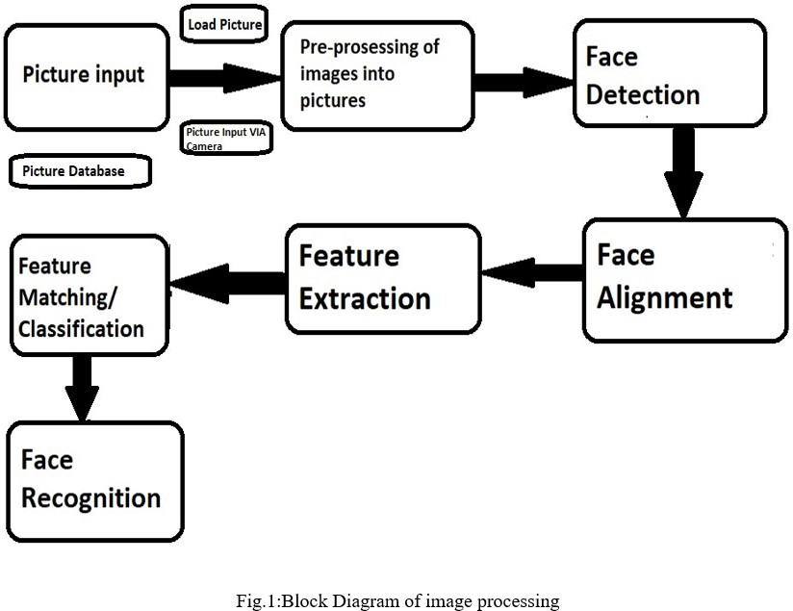

- fig 6.1 system design
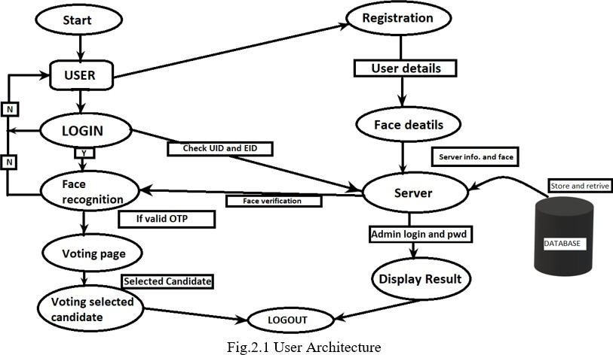
- fig 6.2.1 system architecture
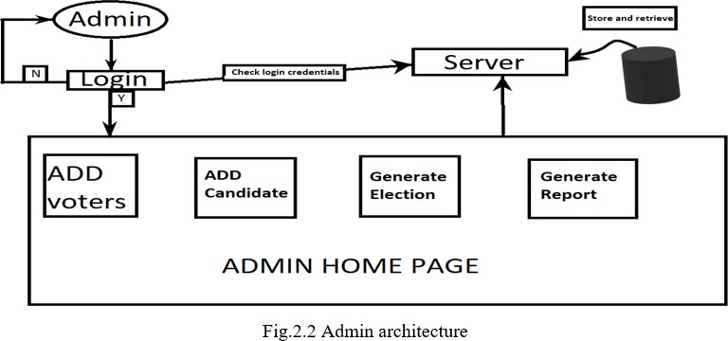
15

- fig 6.2.2 system architecture

label1=Label(R1,image=photo_image) label1.place(x=0,y=0)
la=Label(R1,text="SMART VOTING SYSTEM WITH FACE RECOGNITION",font=(’algerian’,15,
la.place(x=200,y=100)
Registerbt = Button(R1,text = "ADMIN",width=17,height=2,font=(’algerian’,15,’bold Registerbt.place(x =180 ,y=475)
image1=Image.open(’Admin-icon.png’) image1=image1.resize((250,250)) photo_image1=ImageTk.PhotoImage(image1) label2=tkinter.Label(R1,image=photo_image1) label2.place(x=170,y=200)
loginbt = Button(R1,text = "USERS",width=17,height=2,font=(’algerian’,15,’bold’), loginbt.place( x =510,y=475)
image2=Image.open(’user.png’) image2=image2.resize((250,250)) photo_image2=ImageTk.PhotoImage(image2) label3=tkinter.Label(R1,image=photo_image2) label3.place(x=500,y=200)
R1.mainloop()

Chapter 8

Conclusion
The implementation of a smart voting system using facial recognition technology repre- sents a significant advancement in the electoral process, offering numerous benefits while also presenting challenges that must be carefully managed. The integration of biometric verification enhances security by ensuring that only eligible voters can cast their ballots, thereby minimizing the potential for voter fraud and ensuring the integrity of election out- comes. Additionally, the system can streamline the voting process, reducing wait times and improving overall voter experience. By utilizing facial recognition, polling stations can operate more efficiently, accommodating a higher volume of voters with greater speed and accuracy. However, the success of this technology is contingent upon addressing crit- ical concerns surrounding privacy and data security. It is essential that voter data is collected, stored, and processed in compliance with stringent data protection regulations, such as GDPR, to protect individuals’ rights and build public trust in the system. Fur- thermore, addressing the potential for demographic bias in facial recognition algorithms is vital to ensure equitable access and treatment for all voters, regardless of age, gender, or ethnicity. To achieve widespread acceptance and successful implementation, public education campaigns must inform voters about the benefits of the system, how it works, and the measures in place to protect their personal information. Overall, while the shift towards a smart voting system using facial recognition presents an innovative solution to modern electoral challenges, it requires a commitment to transparency, security, and inclusivity to fully realize its potential and foster public confidence in the democratic process.

References
- Nunna Ramya, M. Kandan, Koppula Durgga Devi, Kasari Durga Navya Sri, and Nunns Krishna Vamsi[1] (2021). Smart Voting System using Face Detection and Recog- nition Algorithm. IEEE.

- L.Vetrivendan, Dr.R.Viswanathan, J.AngelinBlessy (2018). Smart Voting System Supportthrough Face Recognition. ISSN (Online) 2394-2320.

- Mrs. Sowmya, Aishwarya, Anusha, Boomika, and Chaitra[3] 2023. SMART VOT- ING SYSTEM THROUGH FACE RECOGNITION USING FACENET ALGORITHM. ISSN (O) 2278-1021, ISSN (P) 2319-5940.

- Kim, J., Joo, M., Choi, J., Kim, J., Jung, C. (2020): Secure and efficient e-voting system using blockchain, homomorphic encryption, and elliptic curve digital signature algorithm.

- Yan and Zhang (2019) A Radial Basis Function (RBF) neural network-based face recognition technique. IEEE.

- Yamini, K., Kumar, S. M., Sonia, S., Yugandhar, P. V, Bharath, T. (2019). Class Attendance Using Face Detection and Recognition with OPENCV. 3822–3826.

- Soomro, Z. A., Ali, A. (2020). FPGA based real- time face authorization system for electronic voting system.

- Chen, X., Zhang, Q., Li, Z. (2021). ”A Comparative Study of RBF and Deep Learning Approaches for Face Recognition in Voting Systems.” Proceedings of the Inter- national Joint Conference on Artificial Intelligence (IJCAI), 2098-2105.

- Mrs.Sowmya., Aishwarya, Anusha N3, Boomika , Chaitra SMART VOTING SYS- TEM THROUGH FACE RECOGNITION USING FACENET ALGORITHM.

- Patel, C. I., Patel, R. (2013). Robust Face Recognition Using Distance Ma- trix.International Journal of Computer

